… on Wednesday, January 2, 2019, you didn’t miss a thing. There was no meeting the day after New Year’s Day. Enjoy the rest of your holiday. See you all back on January 9th.

Yours in Rotary Service,
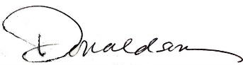
Loren, 7:10 Missed the Meeting Editor
Westminster7:10 Rotary Club

