… on Wednesday, February 22, 2017, you missed a very informative presentation by Sheryl Skattum who talked about a 6th grade reading program and how important reading is to everyday life.
President Barbara opened the meeting at 7:10 a.m. Garth Godwin, our Family of Rotary Rotarian, led us in the Pledge. Eric presented a very meaningful and thankful invocation. President Barbara, being on top of things, then jumped right in and introduced our very efficient Secretary, Ryan Holocher, who introduced guest speaker, Sheryl Skattum . and other guests: Scott Davis, Dennis Reed, Pat and John Zemyan, Kim Skatum and prospective member, Scott Williams.
President’s Announcements:
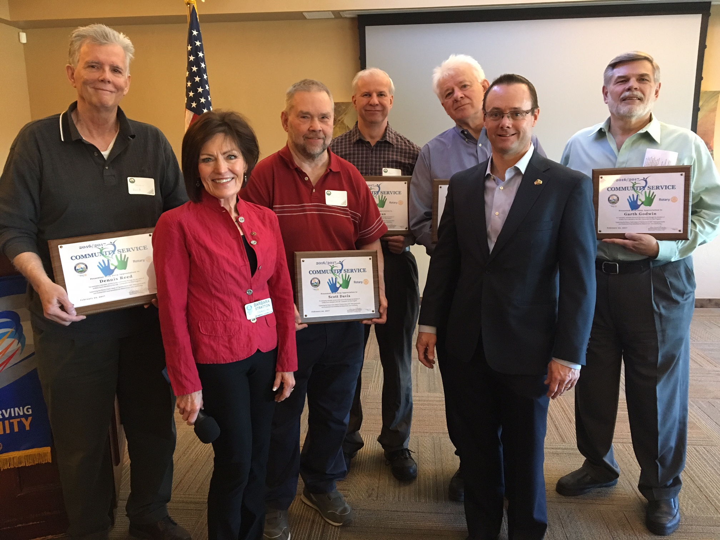
- Barbara asked members to take Roast information to a variety of Rotary clubs this week. Please call her if you would like to help with this.
- Barbara introduced the C4K team which was awarded the 7:10 Rotary Club Community Service Award. The team includes Garth Godwin, John and Pat Zemyan, Scott Davis and Dennis Reed

Other Announcements:

- Mellissa is taking on the Silent Auction for the Roast. She is asking for help with this project. Please sign up to help.
- Martin gave us an update about Rotary International. He also talked about Recognition Points that can be used toward your next Paul Harris Fellow award.
- Betsy thanked the club for the $1000 donation to the Hospital foundation for the inoculation program that will immunize a whole bunch of kids.

Daniel, our Sgt. at Arms this week, made some sizable extractions from the very energetic Rotarians who actually attended the meeting. Don’t forget, you can makeup missed meetings at any of the Rotary Clubs in our area. Get the app, Rotary Club Locator, for your smart phone. You will find clubs you can attend located all over the world.

Garth was extolled by President Barbara who thanked him for being an important member of the 7:10 Rotary Club and who has shown us the Service Above Self motto. His prolific profile as the Family of Rotary Rotarian can be found on the front page of the Bemis award winning, Frameable, Ineluctable, EarlyWord newsletter which was profusely available on all of the tables in its elegant 11x17" format. It can also be found on the 7:10 web site at: www.westminster710rotary.org/newsletter.cfm.

Due to the Community Service Award presentation we closed the meeting very late with a rousing rending of The Four Way Test.

Yours in Rotary Service, Loren

