… on Wednesday, April 5, 2017, you missed a very informative presentation by Brooke Milinazzo who presented a very interesting program about a Wish for Wheels. The mission is to transform qualified families with a bicycle.
President Barbara opened the meeting at 7:10 a.m. Brian Hall, our Family of Rotary Rotarian, led us in the Pledge. Kinoti presented a very meaningful and thankful invocation. President Barbara, being on top of things, then jumped right in and introduced our very efficient Secretary, Ryan Holocher, who introduced guest speaker, Brooke Milinazzo . and other guests: David Rsuchiu, Justin Dituri, Don Rohlfs, Camber Rohlfs Jacob Rohlfs.
President’s Announcements:
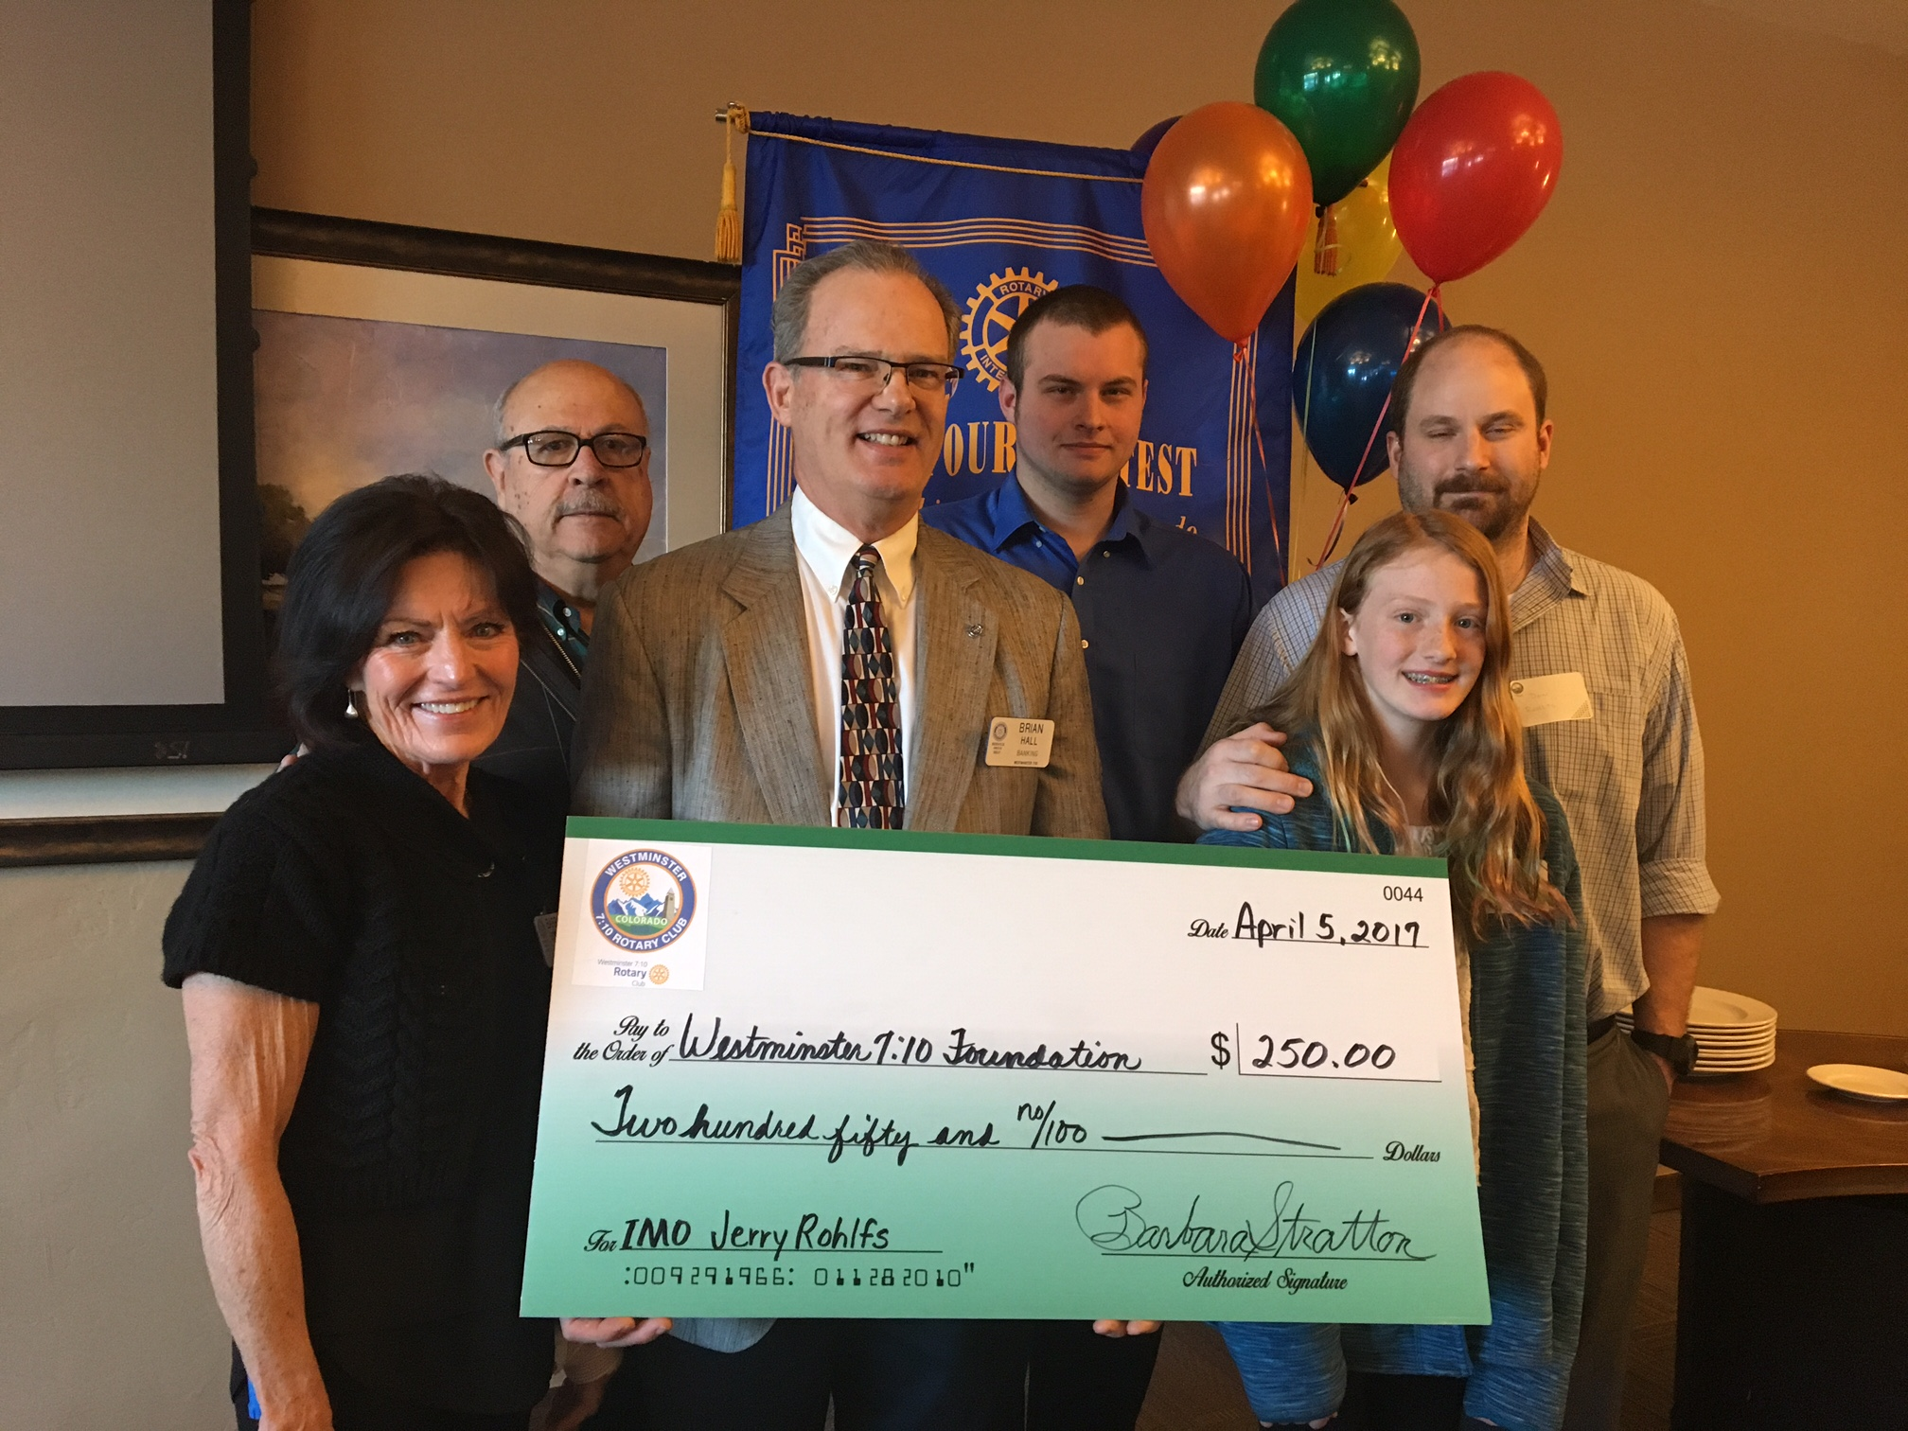
- Barbara introduced David Rsuchiu, our guest from Kenya.
- Barbara along with Brian and Joe T. made a presentation to the Rotary Foundation in memory of Jerry Rohlfs. The 7:10 Club gave $250.00 to the 7:10 Foundation with a presentation of this check.
- Barbara reminded us to sign up for a table or an individual seat at the Roast on April 22.

Other Announcements:
- Wayne introduced Justin from the Noon club as a visitor. He also introduced us to the BOGO program. Bring a visitor who joins our club and you will get a free quarterly dues payment.
- Blaine needs help with RYLA scholarships in May. Call him if you can help.
- Mark H. urged us to bring wine for the Roast. Also, pick up a basket from Mark and ask your business neighbor to fill the basket for a door prize.
- Dave promoted Child Abuse awareness with the pinwheels. You can get yours for only $5.00. Dave will match your purchase.
- Garth announced there will be two more distributions soon. Once these are done we will have given out 9,000 computers. This program has been going for 17 years.
- Ryan updated us about the Golf Tournament coming up on June 26th. The proceeds will provide scholarships to our local high school seniors.
- Brian told us about two more social events coming up. Stay tuned for more information.

Ryan, our Sgt. at Arms this week, made some sizable extractions from the very energetic Rotarians who attended the meeting. Don’t forget, you can makeup missed meetings at any of the Rotary Clubs in our area. Get the app, Rotary Club Locator, for your smart phone. You will find clubs you can attend located all over the world.

Brian was extolled by President Barbara who thanked him for being an important member of the 7:10 Rotary Club and who has shown us the Service Above Self motto. His prolific profile as the Family of Rotary Rotarian can be found on the front page of the Bemis award winning, Frameable, Ineluctable, EarlyWord newsletter which was profusely available on all of the tables in its elegant 11x17" format. It can also be found on the 7:10 web site at: www.westminster710rotary.org/newsletter.cfm.

President Barbara presented our next Rotary member who answered the question, Why I’m A Rotarian. Kevin gave a moving talk about what Rotary means to him.

Joe T. had a Thought for the Day.

We closed the meeting right on time with a rousing rending of The Four Way Test.

Yours in Rotary Service, Loren

