Volume 1
July 3, 2019
Westminster 7:10 Rotary Club
The Bemis Award Winning, Frameable, Ineluctable* EarlyWord NEWSLETTER SUMMER EDITION

A Note:

Due to the July 4th Holiday,
the 7:10 Rotary Club was Dark on July 3rd.
Therefore, you didn’t miss the meeting.
We’ll be back in force on July 10th.
See y’all then.

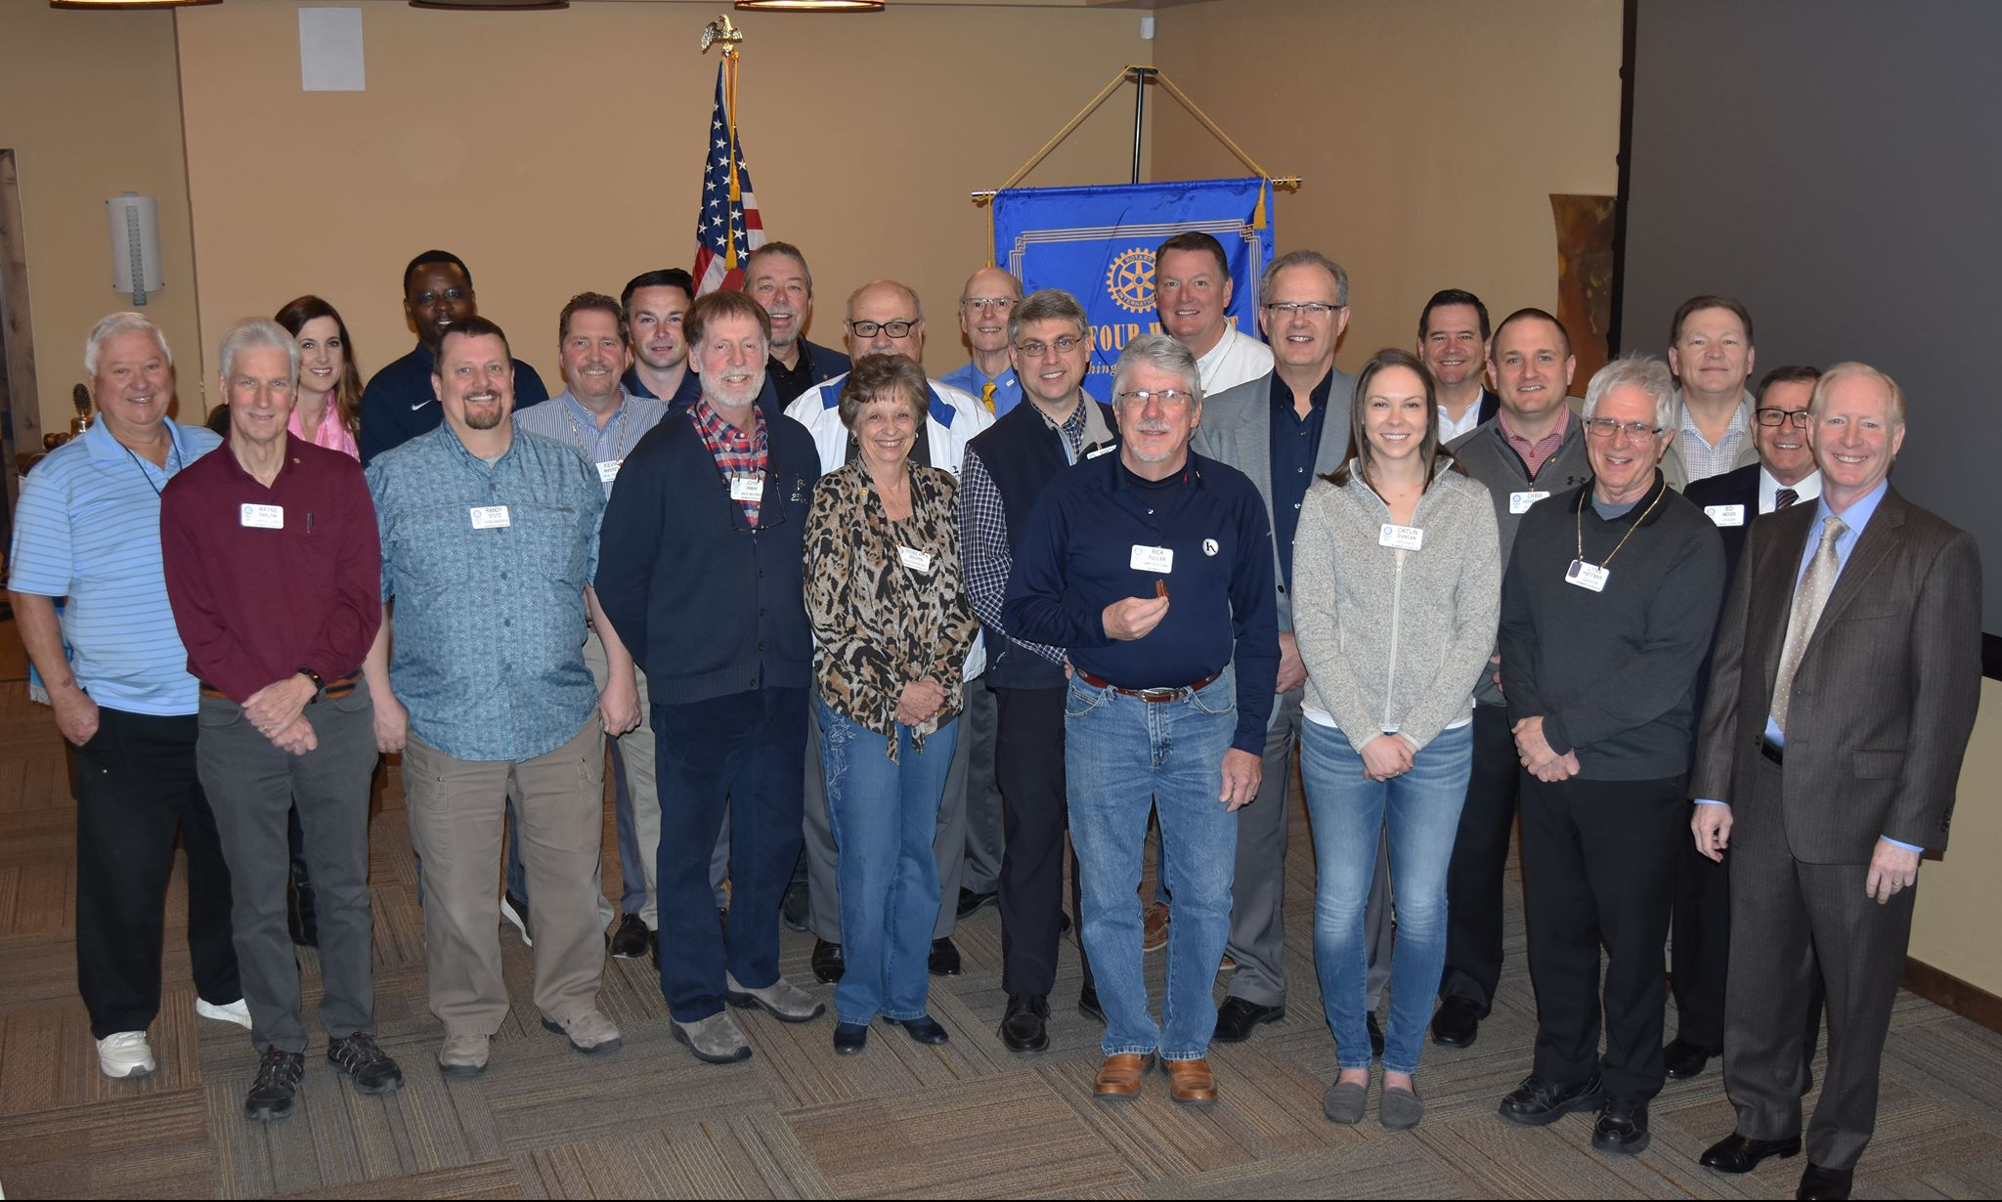

Happy New Year!

