… on Wednesday, July 11, 2018, President Chris opened the meeting promptly at 7:10 a.m. Tom Wilson, our Family of Rotary Rotarian, led us in the Pledge. Kevin presented a very meaningful and thankful invocation. President Chris, being on top of things, then jumped right in and introduced our very efficient Secretary, Randy Stutz, who introduced guest speaker, and other guests.
President’s Announcements:
- Chris introduced our newest member, Joe Duncan, who is rejoining us after a 2-year hiatus.

Other Announcements:
- Joe updated us about his new job with C4K. We received several computers and will give out 5 laptops to Hope House.
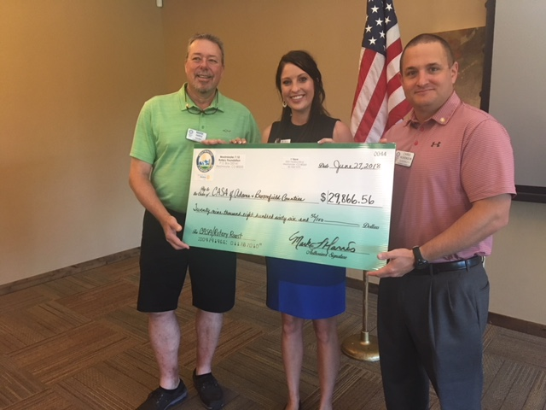
- Mark and Chris presented Lindsay Lierman, the director or CASA, with a big check as their share of the proceeds of the Rotary / CASA roast.
- Loren presented Doug Hall with the Sgt.at Arms award. He raised the most money in club fines.
- Brian updated us with social events. The Horse Races will be announced later.
There are some outdoor concerts available. For more information give Brian a call.
- Caitlin updated us about our peach sales. Deadline for orders is August 1st. Get your orders in as soon as possible.

Our program this morning was a very informative presentation called Paladin Rescue Alliance by Emily Stucky. She described the issues with Human Trafficking throughout the world and specifically in Thailand.
Melissa, our Sgt. at Arms this week, made some sizable extractions from the few, but very energetic, Rotarians who attended the meeting. Don’t forget, you can makeup missed meetings at any of the Rotary Clubs in our area. Get the app, Rotary Club Locator, for your smart phone. You will find clubs you can attend located all over the world.

Tom was extolled by President Chris who thanked him for being an important member of the 7:10 Rotary Club and who has shown us the Service Above Self motto. His prolific profile as the Family of Rotary Rotarian can be found on the front page of the Bemis award winning, Frameable, Ineluctable, EarlyWord newsletter which was profusely available on all of the tables in its elegant 11x17" format. It can also be found on the 7:10 web site at: www.westminster710rotary.org/newsletter.cfm.

President Chris presented Martin who gave us a short Rotary Moment. He gave us a recap of the Rotary International Conference in Toronto he recently attended. He also encouraged all of us to make time to attend an International Conference.

Joe T. had a Thought for the Day.

We closed the meeting right on time with a rousing rending of The Four Way Test.

Yours in Rotary Service, Loren

