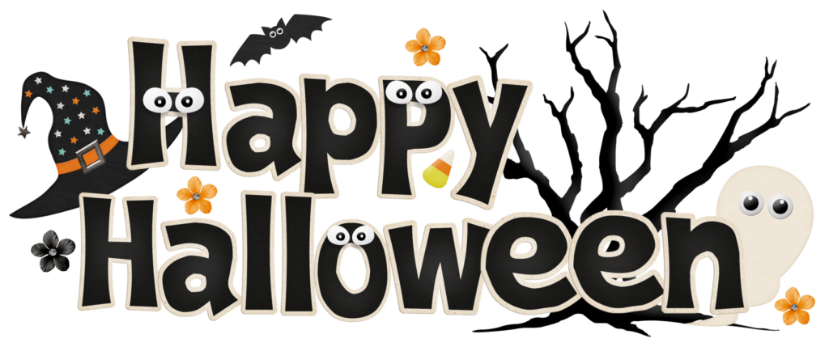

… on Wednesday, October 31, 2018, President Chris promptly opened the meeting at 7:10 a.m. Roger, our Family of Rotary Rotarian, was absent this morning, so Greg Moser, a prospective member, led us in the Pledge. Kevin presented a very meaningful and thankful invocation. President Chris, being on top of things, then jumped right in and introduced our very efficient Secretary, Randy Stutz, who introduced guest speaker, and other guests.
President’s Announcements:
- President Chris welcomed everyone to the meeting this morning.
- Chris reminded us about the Leadership Class coming up at Red Rocks CC. Sign up on the District website.

Other Announcements:
- Mark H. is asking for one of us to step up and chair the Foundation Request Committee. Please see Mark if you have an interest in this committee. It is with gratitude that Ed Moss just stepped up and volunteered to head this group. Thank you, Ed.
- John updated us about Dictionaries. Members are going out now to distribute dictionaries to schools.
- Melissa is passing around the signup sheet for our Thanksgiving Basket program. Please sign up for food and to transport the boxes. Collection will be on November 14th. We will assemble the items on that day during the meeting.

Our program this morning was a very informative presentation by David Cohn who talked about Leadership and Self-Mastery.
Melissa, our Sgt. at Arms this week, made some sizable extractions from the few, but very energetic, Rotarians who attended the meeting. Don’t forget, you can makeup missed meetings at any of the Rotary Clubs in our area. Get the app, Rotary Club Locator, for your smart phone. You will find clubs you can attend located all over the world.

Roger was extolled by President Chris who thanked him for being an important member of the 7:10 Rotary Club and who has shown us the Service Above Self motto. His prolific profile as the Family of Rotary Rotarian can be found on the front page of the Bemis award winning, Frameable, Ineluctable, EarlyWord newsletter which was profusely available on all of the tables in its elegant 11x17" format. It can also be found on the 7:10 web site at: www.westminster710rotary.org/newsletter.cfm.

Rick gave us a short Rotary Moment about the Rotary Polio eradication program.

Rick had a Thought for the Day.

We closed the meeting right on time with a rousing rending of The Four Way Test.

Yours in Rotary Service,
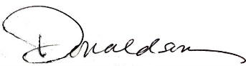
Loren, 7:10 Missed the Meeting Editor
Westminster7:10 Rotary Club

