… on Wednesday, November 14, 2018, President Chris promptly opened the meeting at 7:10 a.m. Brian Hall, our Family of Rotary Rotarian, was absent this morning so Randy led us in the Pledge. Eric presented a very meaningful and thankful invocation. President Chris, being on top of things, then jumped right in and introduced our very efficient Secretary, Randy Stutz, who introduced guest speaker, and other guests.
President’s Announcements:
- Chris welcomed each Rotarian to a very packed program today.
- Chris passed around a signup sheet for the Santa’s Workshop helpers. This will take place on the first three Saturdays in December. Call him if you need more information.

Other Announcements:
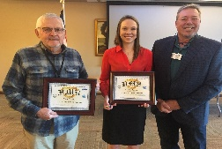
- Caitlin talked about our Adopt-A-Child program coming on December 14.
- John is urging everyone to get Dictionaries distributed as soon as possible.
- Joe thanked all the folks who helped with the C4K cleanup last Saturday.
- Mark Harris made a very special presentation to Tom and Caitlin, pictured right, who received their H. Michael Fellow Awards. Tom received his 4th HMH Award and Caitlin her first.

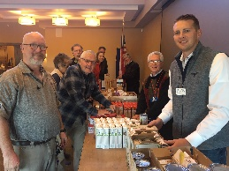
Our programs this morning included a very informative presentation by Brittany Polinski about Precious Child, a non-profit which assists those in need with clothing, food items and educational tools to use in school.
We also had the opportunity to fill 40 Thanksgiving Baskets for those who need them. Several energic Rotarians, pictured right, pitched in and brought food and boxes to fill, then took time at the meeting to fill these boxes for the folks at the Senior Hub of Westminster to share with families in the Westminster area.
Mark Clark, our Sgt. at Arms this week, made some sizable extractions from the few, but very energetic, Rotarians who attended the meeting. Don’t forget, you can makeup missed meetings at any of the Rotary Clubs in our area. Get the app, Rotary Club Locator, for your smart phone. You will find clubs you can attend located all over the world.

Brian was extolled by President Chris who thanked him for being an important member of the 7:10 Rotary Club and who has shown us the Service Above Self motto. His prolific profile as the Family of Rotary Rotarian can be found on the front page of the Bemis award winning, Frameable, Ineluctable, EarlyWord newsletter which was profusely available on all of the tables in its elegant 11x17" format. It can also be found on the 7:10 web site at: www.westminster710rotary.org/newsletter.cfm.

After a very full program today we closed the meeting right on time without a rousing rending of The Four Way Test.

Yours in Rotary Service,
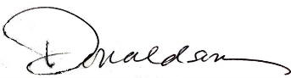
Loren, 7:10 Missed the Meeting Editor
Westminster7:10 Rotary Club

