… on Wednesday, December , 2018,you didn’t miss a thing. There was no meeting this day after Christmas. Enjoy the rest of your holiday. We will also be DARK on January 2, 2019. See you all back on January 9th.

Yours in Rotary Service,
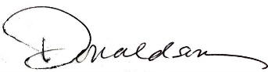
Loren, 7:10 Missed the Meeting Editor
Westminster7:10 Rotary Club

