If You Missed the Meeting…
Greetings 7:10 Rotarians and Friends,
If you missed the meeting on Wednesday, March 29, 2016, you missed a very informative presentation and tour by our hosts Irene Tynes, Angela Mariotti, Ashley Penman and Sister Pat Hayden, all Administrators and Officers at St. Anthony North Medical Center.
President Mark opened the meeting at 7:10 a.m. then promptly turned the meeting over to our hosts. At that point we disbanded with all other formalities and walked the grounds of the hospital. We did have one guest: Wega Kenoti.
As we arrive at St. Anthony North Medical facility, we are impressed with the ease of parking and the entrance to the magnificent three story lobby. | 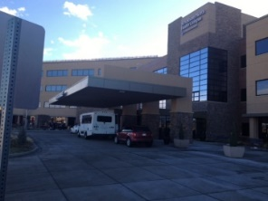 |  | As our guides take us to a conference room we are regaled with a beautifully prepared buffet breakfast including Bagels, bacon, sausage, scrambled eggs and hashed browns.
The meeting room is well appointed with two large projection screens and a closed circuit television monitor. | 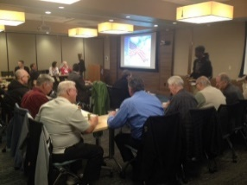 |  | Members enjoy breakfast around tables laid out facing the big screens. As an introduction to our tour, our hosts do a well-planned presentation which guides us through the many sections of the hospital.
Inside the front entry, we are treated to a three story rotunda with sculptures, trees, and artwork. | 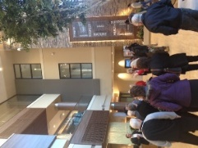 | 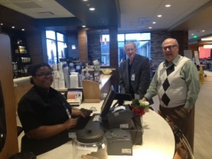 | Of course, Jerry and Joe had to take a break and enjoy a handmade cup of java provided by Peets Coffee company, and right after breakfast, as well.
From the second floor of the entryway we get a glimpse of the outside campus looking north through some magnificent windows | 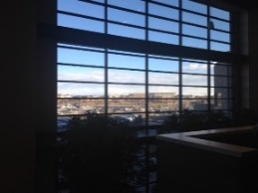 | 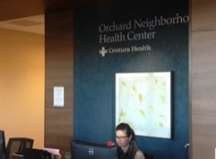 | Part of the hospital includes the Neighborhood Health Center. This is used for non-emergency cases, day care, and physical therapy functions.
The outside patio is just to the west of the main entrance and is a beautiful setting to relax and be with friends and family members. Seen here are comfortable couches, a fireplace and even a gas grill for guests to use. | 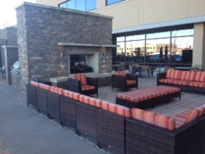 | 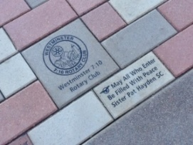 | Of course, shown prominently in the brickwork of the patio is a brick with our logo which the 7:10 Rotary Club donated two years ago as part of the fundraising to build this beautiful facility.
Yours in Rotary Service, Loren

